Žamberk, Pardubice Region, Czech Republic
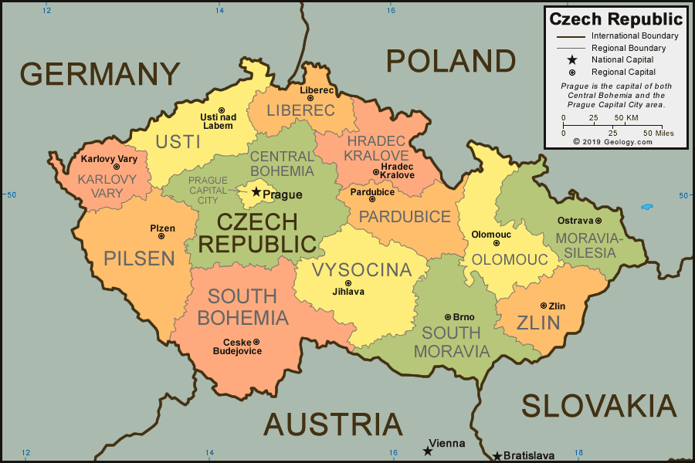
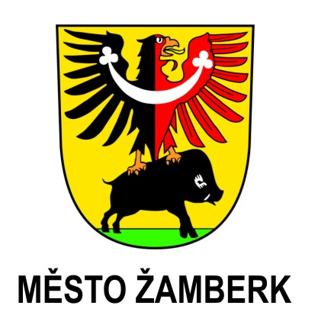
By students from Žamberk Czech Republic
Population: 6 000

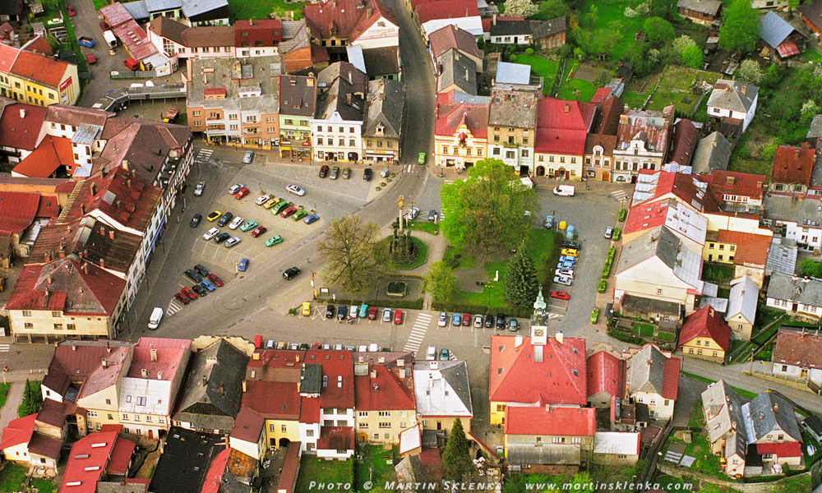

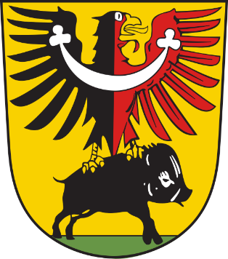
Žamberk is a town in the Ústí nad Orlicí District, Pardubice Region of the Czech Republic. It has about 6,000 inhabitants.
The first record of the town is from 1332.
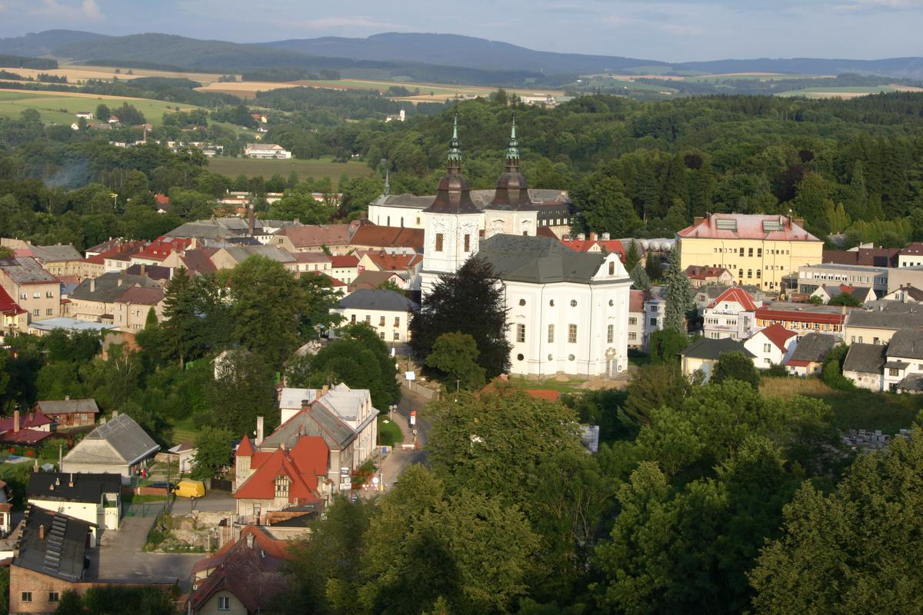
Sister cities
- Fresagrandinaria (Italy)
- Miharu (Japan)
- Nowa Sól (Poland)
- Püttlingen (Germany)
- Rice Lake, Wisconsin (USA)
- Saint-Michel-sur-Orge (France)
- Senftenberg (Germany)
- Senftenberg (Austria
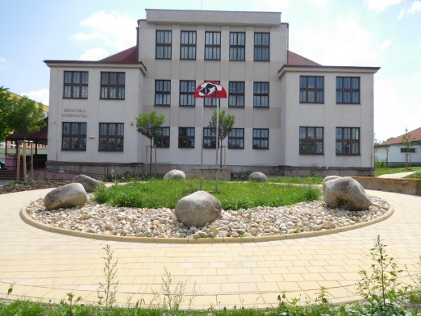
.Veszprém (Hungary)

Our Town Hall was built the 19th century.
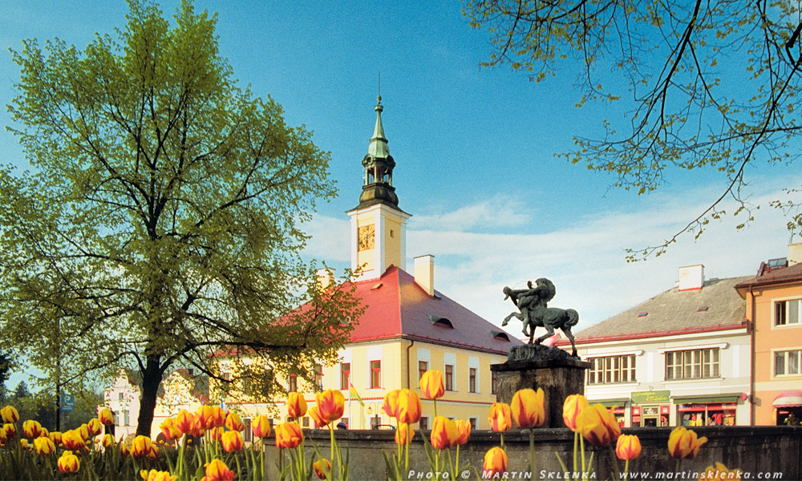

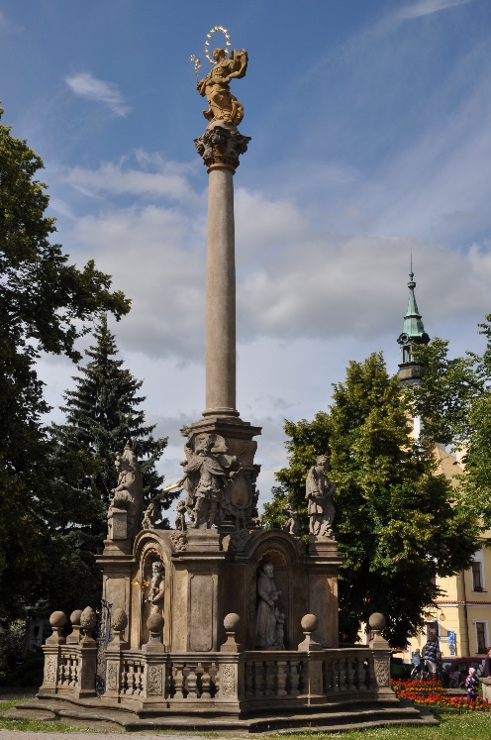
The Plague Monument in the square was built
in the 18th century.

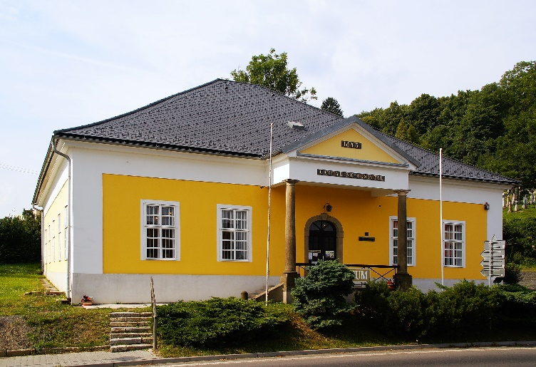
Our Town Museum was founded in 1911. The permanent museum exposition was established between 1974-1975.

The Look out Tower „Rozálka“
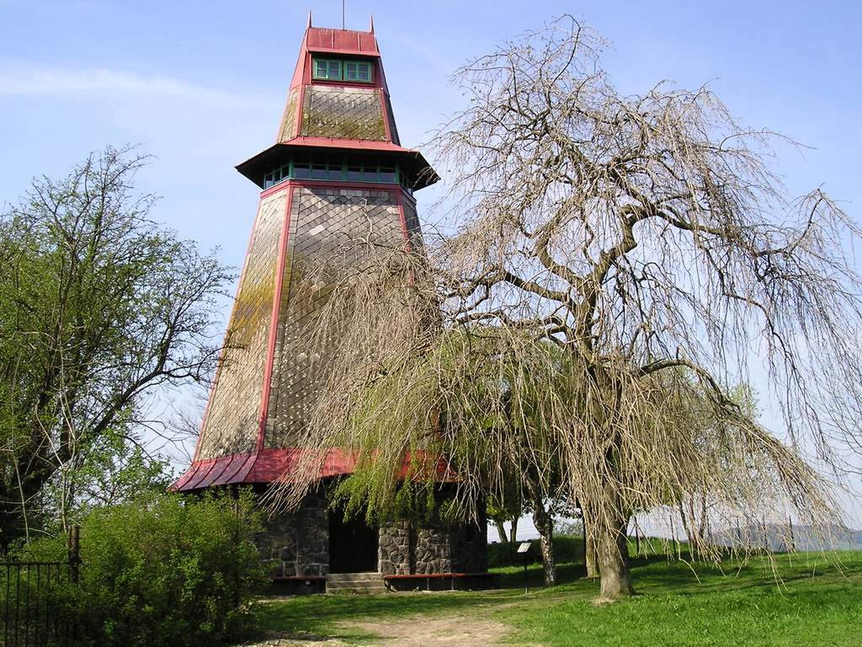
was built on Kapelský
Hill in 1932.

The Diviš´s Theatre was built in 1926.
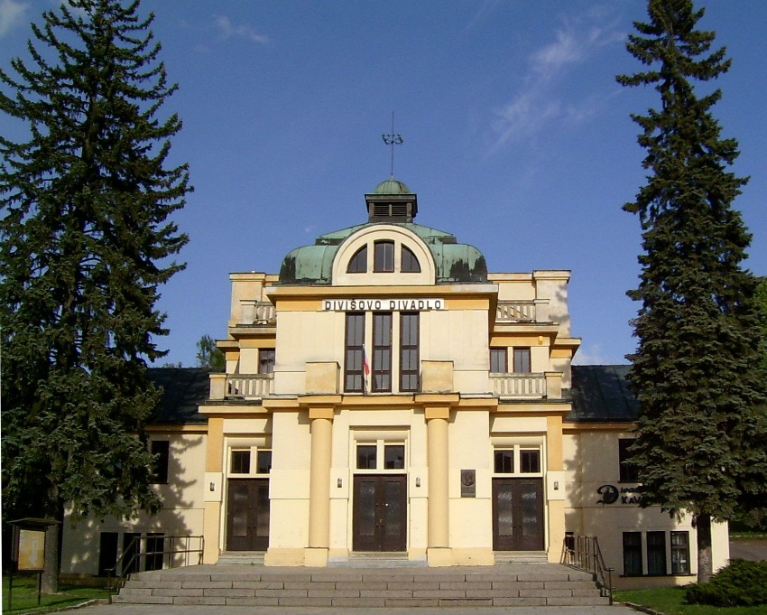

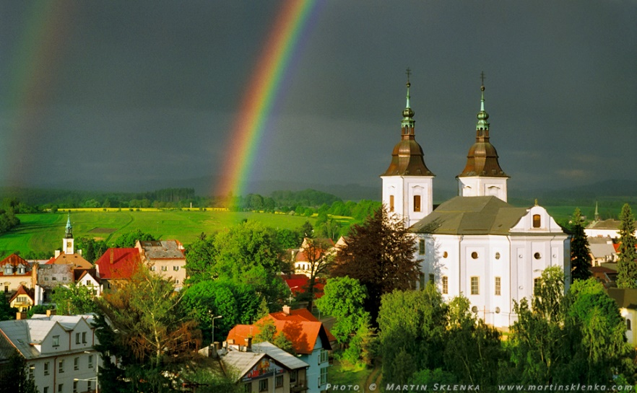
The oldest record of the church is from 1352.
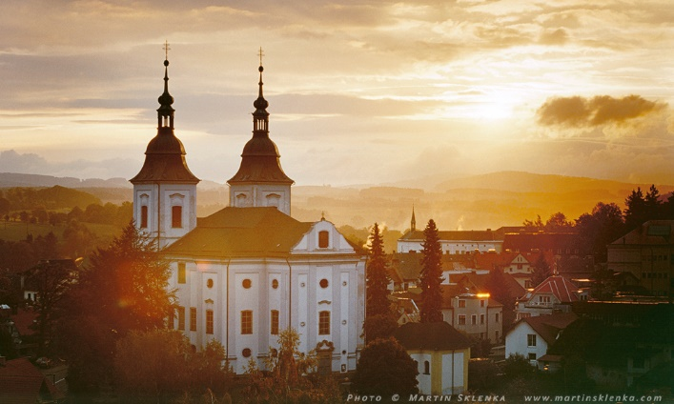
The church is the highest building in Žamberk.
It is 72 metres high.
The currant appearance of the castle is from 1815. At the end of the 19th century the castle was adapted in the secession style.
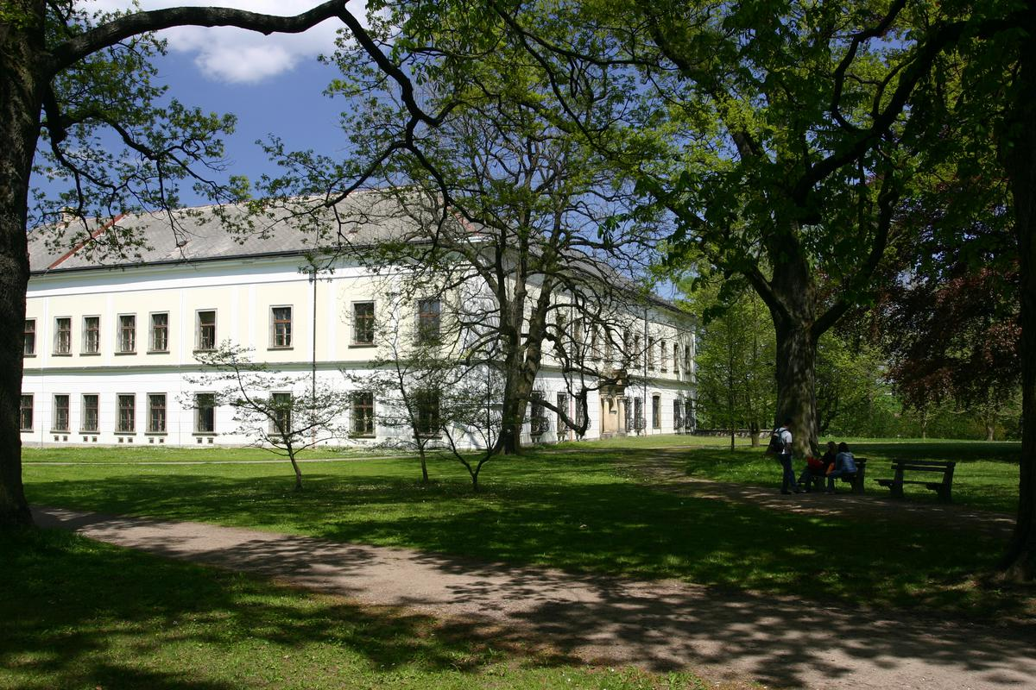

The Jewish Cemetry in our town was founded at the end of the 17th century.The total reconstruction took place between 1993-1995.
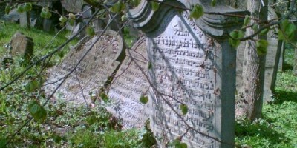

Our school is in the centre of the town.
