Programme in Spain
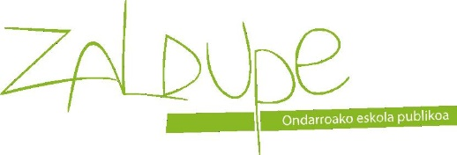
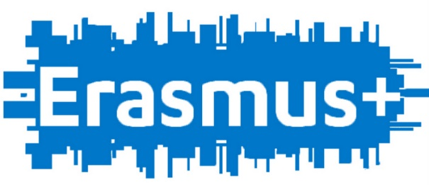
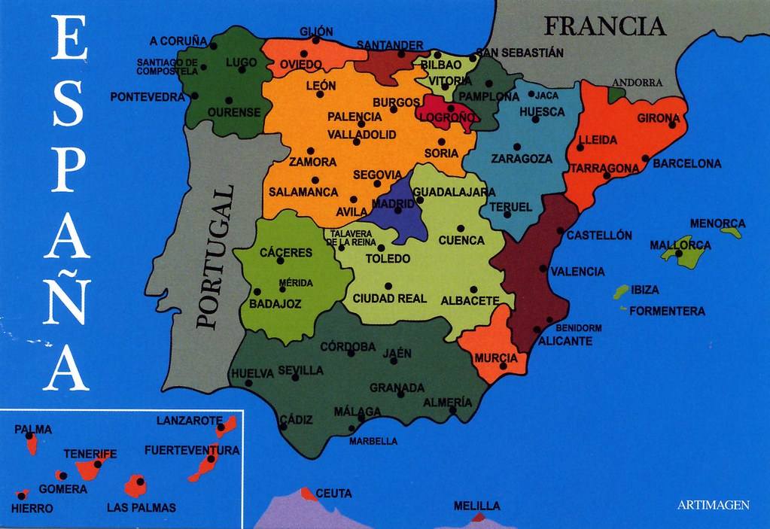

Monday 18th November | 9:30- Welcome at school  11:30- Welcome inTownHall  14:30-Afternoon at school
Tuesday 19th November | Visiting the BIRD CENTER http://www.birdcenter.org/ 4€ each child.
Wednesday 20th November | Visiting Marino’s factory in the morning.  14:30-Afternoon at school
Thursday 21st November | Trip to Bilbao. Guggenheim museum. https://www.guggenheim-bilbao.eus/
Friday, 22nd November | Visiting Ondarroa´s marsh rowing in boats and visit to the rowing club.

