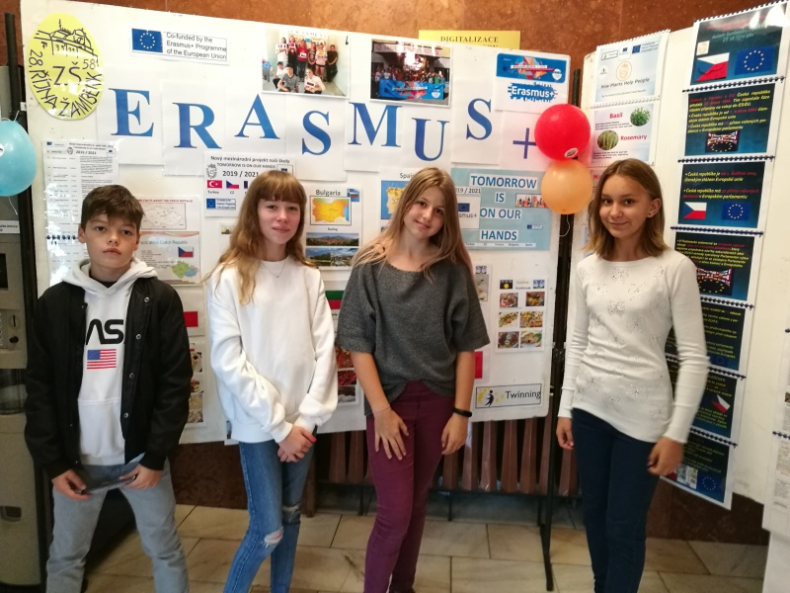
Czech Children Spain 18th – 22nd November 2019

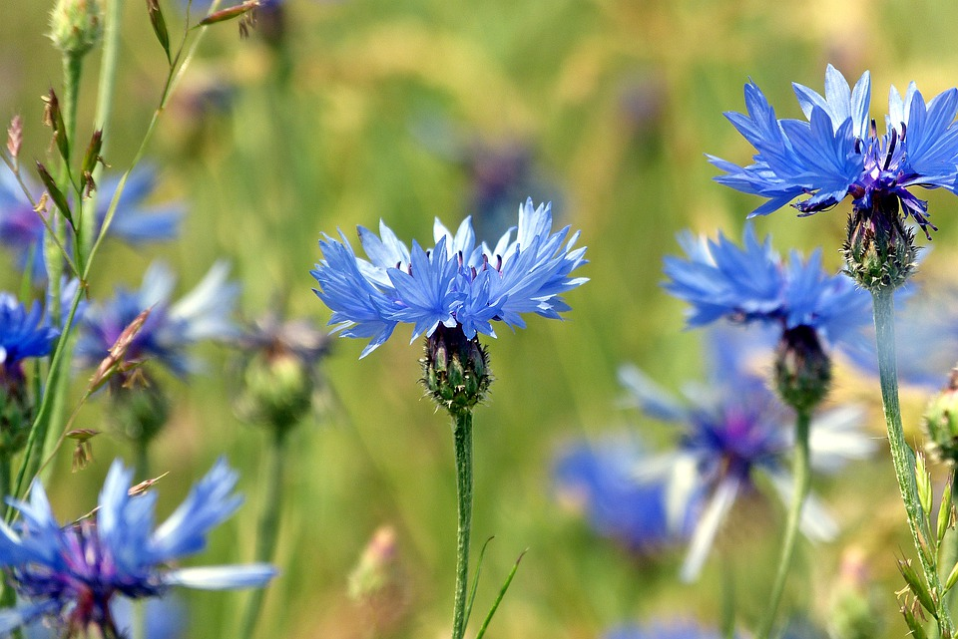

Matous Dorotka Veronika Lucie
12 years old  Likes: PE, IT, English  A deputy head pupil of the class  Likes: playing football, jogging, biking, playing PC games  In summer I like going mountain biking, spending time with friends  In winter I like skiing  Favourite meal:  pizza, pasta | 12 years old  Likes Maths, PE, Civics  Likes: dancing, reading, jogging  Likes: listening to pop music  In summer I like  going to the country house  In winterI like cross country skiing Favourite meal:  fruit dumplings | 12 years old  Likes: English, History, PE, Czech  A member of the School Parlament  Likes: music and plays the trumpet  In summer I like biking and going on trips  In winter I enjoy skating  Favourite meal:  pizza, pancakes | 12 years old  Likes: History, PE, English, Art  A member of the choir Viola  Likes: working in the garden, animals, making Ctristmas cookies, cooking  In summer I like spending time resting in the garden  Favourite meal:  plum dumplings

