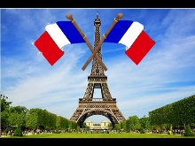
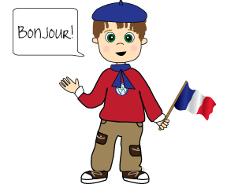
Famous People France
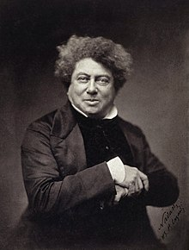
Alexadre Dumas (writer)
The Count of Monte Cristo, The Three Musketeers

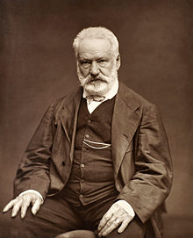
Victor Hugo (writer)
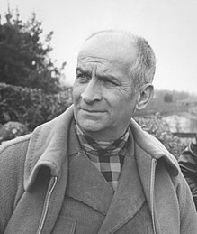
Notre-Dame de Paris, Les Misérables (Bídnici)

Louis de Funès
actor
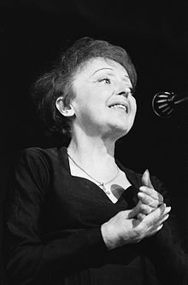
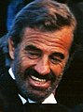
Jean-Paul Belmondo
actor

Edith Piaf Singer
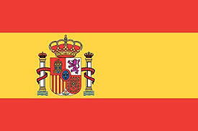
Famous People Spain
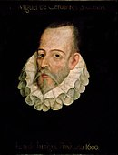
Miguel de Cervantes Saavedra
writer

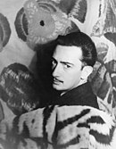
Don Quixote
Salvador Dalí
Painting, drawing, photography, sculpture, writing, film, jewelry
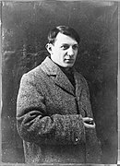
Picasso
Painting, drawing, sculpture, printmaking, ceramics, writing
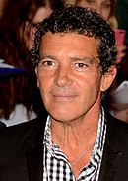
Antonio Banderas
actor

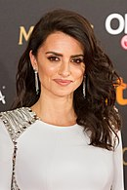
Penélope Cruz
actress, model
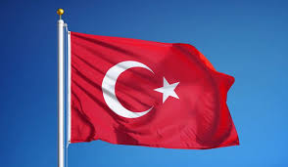
Famous PeopleTurkey
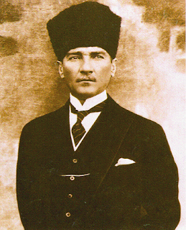
- Mustafa Kemal Ataturk, the Founder of the Turkish Republic (1881-1938)
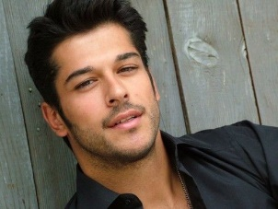
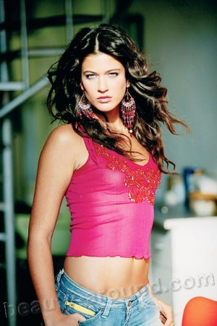
Burak Özçivit Burak Ozcivit was born in Istanbul on December 24, 1984. He is one of the most successful and hot actors of Turkey.
Berrak Tuzunatac (born November 2, 1984, Yalova, Turkey) - actress and model. She worked as the lead on TV, along with the modeling career took acting classes. Her movies: "Women Base", "Envy", "Way of the Dragon," "The sea palm", episode: "Ezel".
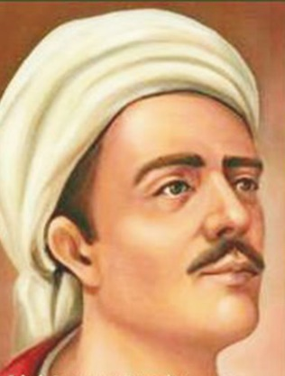
Yunus Emre has exercised immense influence on Turkish literature, from his own day until the present.
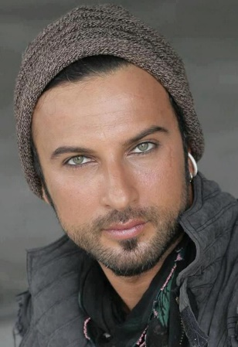
Most famous Turkish singer is probably Tarkan

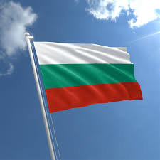
Famous People Bulgaria
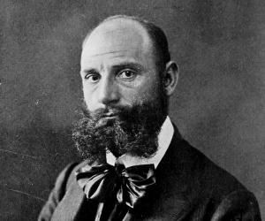
Famous as:
National Hero in Bulgaria
Sandanski was nicknamed ‘Pirin Tsar’ by the villagers as he frequently operated in the Pirin region
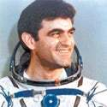
Aleksandr Panayotov Aleksandrov age 67
Aleksandr Panayotov Aleksandrov is a retired Bulgarian cosmonaut. He is the second Bulgarian to have flown to space behind Georgi Ivanov.

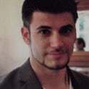
Stanislav Ianevski is a Bulgarian actor who is perhaps best known for playing Viktor Krum in the 2005 film Harry Potter and the Goblet of Fire. Ianevski was born in Sofia, Bulgaria
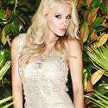
Desislava Ivanova Doneva /DESS/ is a Bulgarian singer, songwriter and producer. Under the name Desi Slava, shhas managed to establish herself as one of the icons of Balkan music

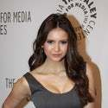
Nina Dobrev is a Bulgarian Canadian actress and model. She played the role of Mia Jones, the single teenage mother, on Degrassi: The Next Generation, from the show's sixth to ninth season.
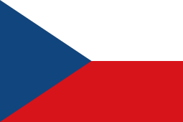
Famous People Czech Republic
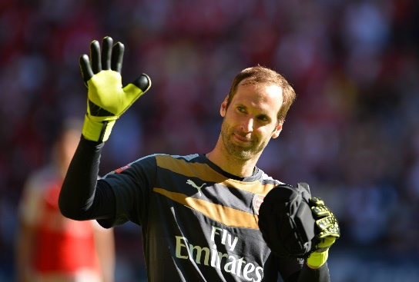
Petr Cech
Football Player
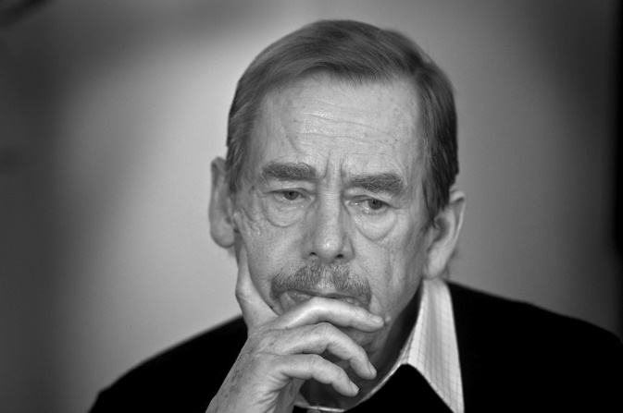
Vaclav Havel
Former President of the
Czech Republic
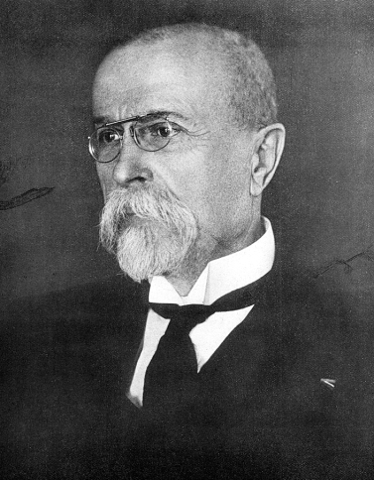
Tomáš Garrigue Masaryk
1st prezident of Czechoslovakia
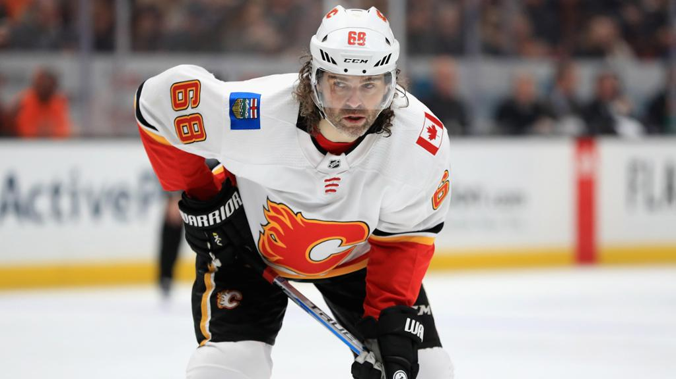
Jaroslav Jagr
Ice hockey player
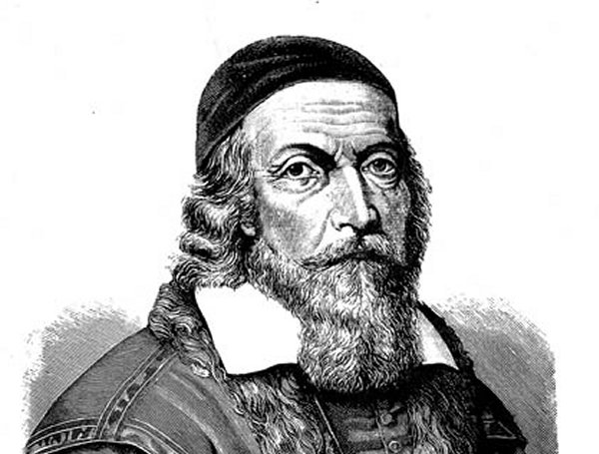
Jan Amos Komenský
teacher, philosopher

