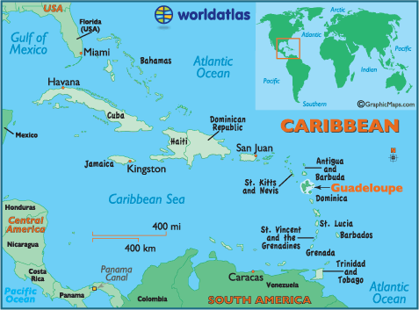
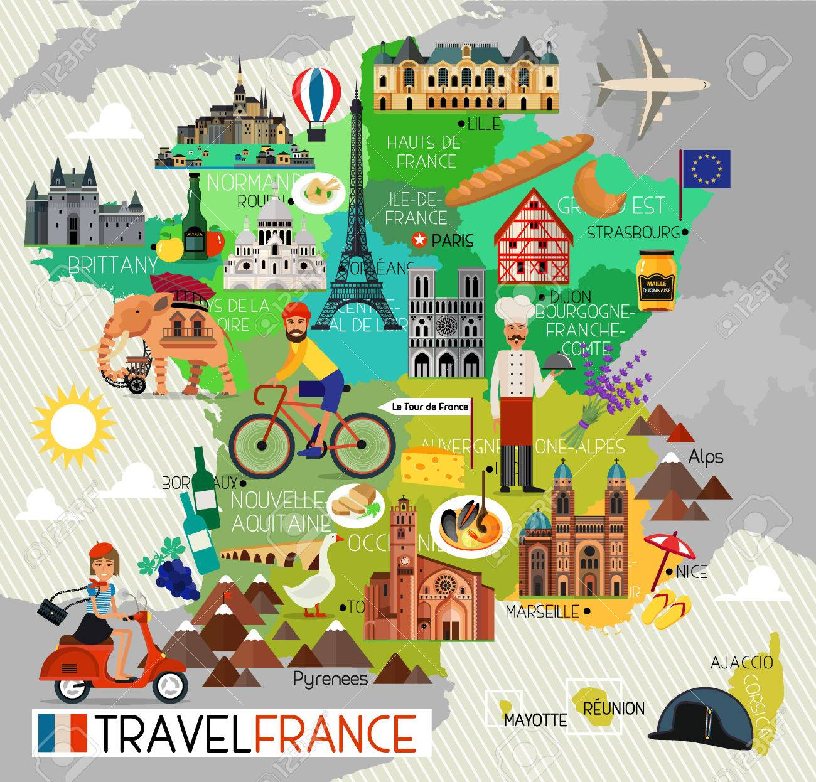
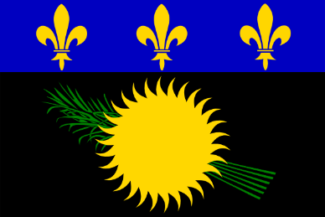
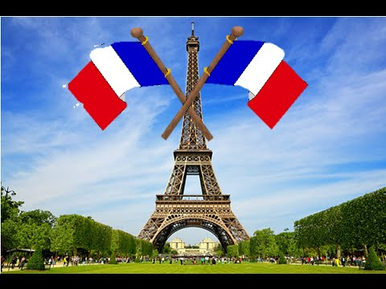
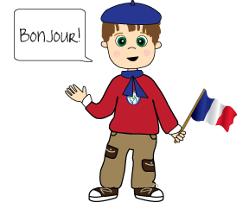
France
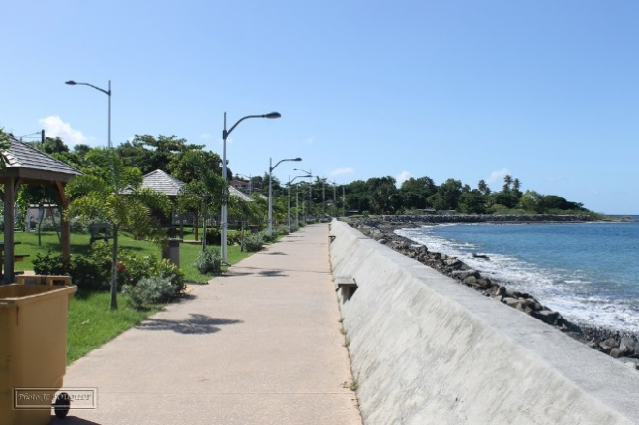
Guadeloup Vieux Habitants ( France)
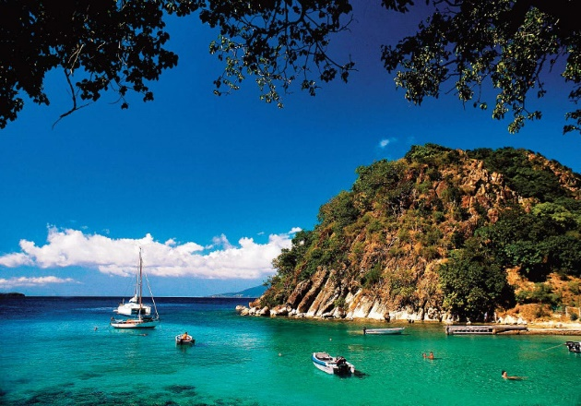

Guadeloupe Islands Fast Facts
Capital: Pointe-à-Pitre
Area: 629 square miles

Population: About a half million people live on the Guadeloupe Islands. The majority is Afro-Caribbean, but sizable minorities of Indians and Caucasian Frenchmen call Guadeloupe home, as do a good number of people who are all of the above. Roman Catholicism is by far and away the dominant religion.
Climate: The Guadeloupe Islands enjoy a temperate tropical climate thanks to the influence of the ocean and trade winds. Throughout the year, the air and water temperatures vary between 24°C and 30°C. Rainfall is very localized, short-lived and generally more common in mountainous areas.
Currency: The currency is the euro (€).
Time Difference: The Guadeloupe Islands share the same time zone as New York and Montreal, namely GMT-5 in winter and GMT-6 in summer.
Voltage: 220 volts. Travelers from North America should carry adapters and transformers with European-style round pins.
Entry Formalities: The Guadeloupe Islands are an integral part of France, and therefore of Europe. A valid identity card or passport is sufficient.
Major Events:
• Carnival
• Terre de Blues – Marie-Galante
• International “Tour de Guadeloupe” Cycling Race
• Kakado Christmas
• All Saint's Festival (November 1st)
• Guadeloupe Film Festival (FEMI)
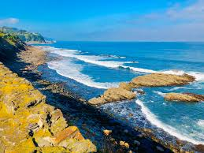
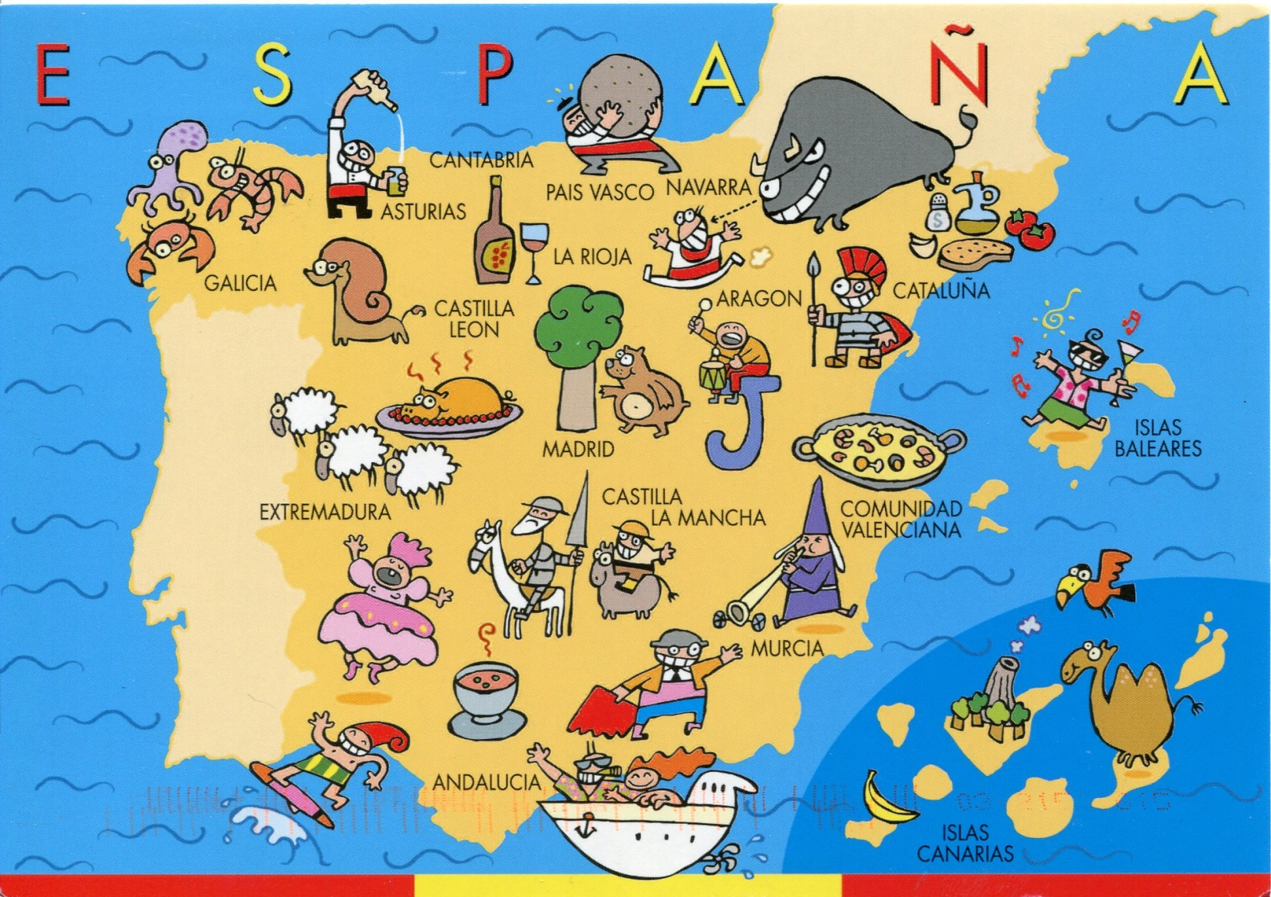
Spain
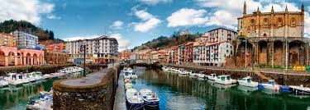
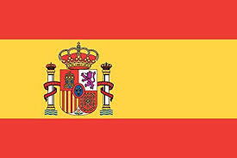
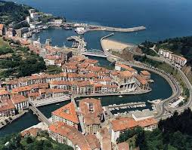
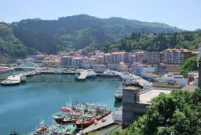
Ondarroa

Some Facts about Spain
- Population: 48 million people live in Spain (2018)
- Capital: Madrid, with 3.3 million inhabitants, is Spain's biggest city.
Name: Reino de España (Kingdom of Spain), short form: España
- Government: Parliamentary Monarchy
- Languages: Castilian Spanish 74%, Catalan 17%, Galician, Basque
- Literacy: More than 98% can read and write.
- Religion: mainly Christians (Roman Catholics 94%)
- Currency: 1 Euro=100 cents, before 2001 Spanish peseta
- National Symbol: The pillars of Hercules, short-toed eagle (national bird), red carnation (national flower). The official Spanish anthem is one of only four anthems in the world without lyrics.
Some interesting facts about Spain's geography:
- Longest river: Rio Ebro with 910km/566 miles
- Largest lake: Mar Menor is also the largest salt lake in Europe
- Highest mountain: El Teide on Tenerife (Canary Islands) with 3,718m/12,198 ft.
- Largest island: Mallorca (which is part of the Balearic Islands)

Spain Facts: Spanish Food
The Spanish main dishes contain: potatoes, rice, fish, meat, beans, chickpeas and fruit.
Paella
- Paella: A rice dish with seafood or meat such as rabbit, chicken and snails, popular especially in Valencia
- Gazpacho: Vegetable soup or stew
- Coca: A sweet bread
- Empanada: Stuffed bread or pie
- Turrón: Nougat sweet cake made with honey and nuts
- Jamón Serrano: Pork leg ham
- Chorizo: Pork sausage

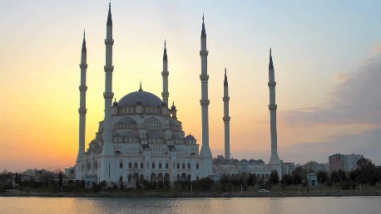
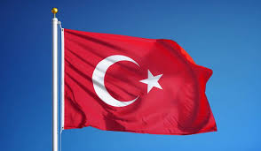
Turkey Mersin

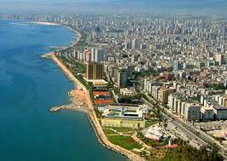
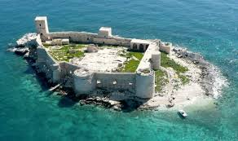

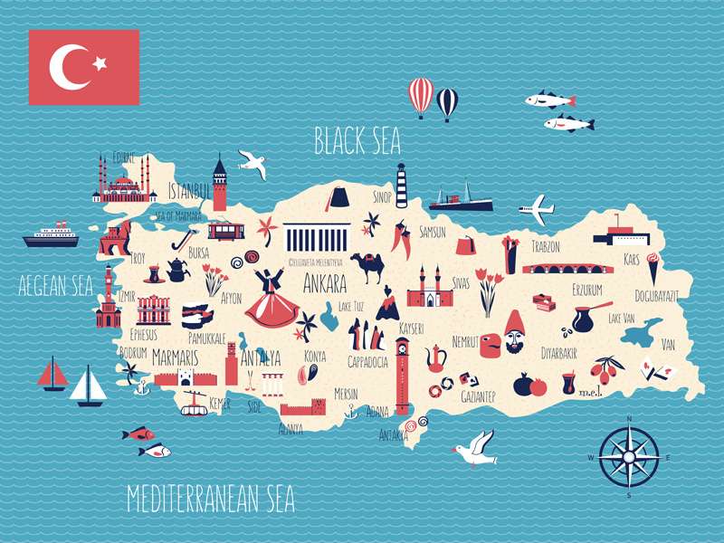

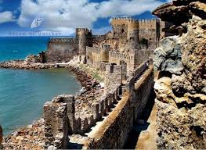
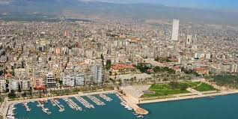

Some Facts about Turkey
- The official name of Turkey is the Republic of Turkey.
- Geographically, Turkey sits in two continents, Europe and Asia, although around 97% of it's land area is on the Asian side.
- The total land area of Turkey is slightly larger than the state of Texas.
- There are eight countries that share a border with Turkey including Armenia, Azerbaijan, Iran, Iraq, Syria, Bulgaria, Greece, and Georgia.
- Just over 80 million people live in Turkey (80,694,485) as of July 2013.
- Istanbul is the largest city in Turkey and is the third most populous urban area in Europe. But it is not the capital, Ankara is in fact the capital of Turkey.
- The highest point in Turkey is Mount Ararat 5137 m (16,854 ft).
- Modern day Turkey was formed in 1923 following the fall of the Ottoman Empire.
- The most famous of Turks is Mustafa Kemal who was adorned with the title 'Ataturk' or 'Father of the Turks' after his contributions to the country's independence.
- Turkey's warm climate is good for growing crops. Livestock and forestry are also important industries.
- Turkey has a strong manufacturing sector, it makes and exports cars, planes, electronics, clothing and textiles.
- The currency used in the country is called the Turkish Lira.
- Many famous ethnic foods come from Turkey such as manti, kebab, Lokum (Turkish delight), baklava, kadayif and more.
- The ancient city of Troy was located in modern day Turkey.
- The most popular sport in Turkey is football (soccer), the Turkish national team came third in the 2002 World Cup Finals.
- Basketball and volleyball are also popular sports in Turkey.
- Because of its location on top of a number plate boundaries Turkey is prone to earthquakes especially in the north of the country.
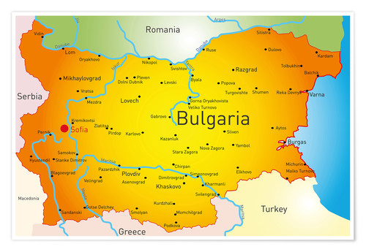
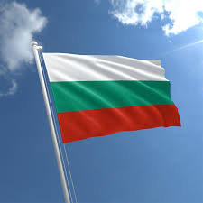
Bulgaria

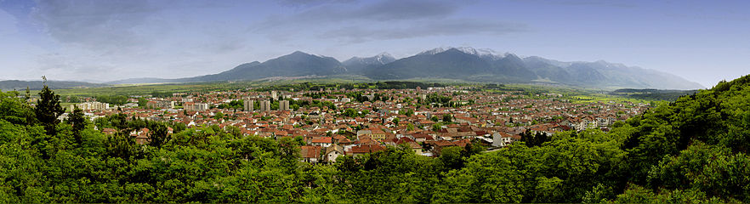
Razlog
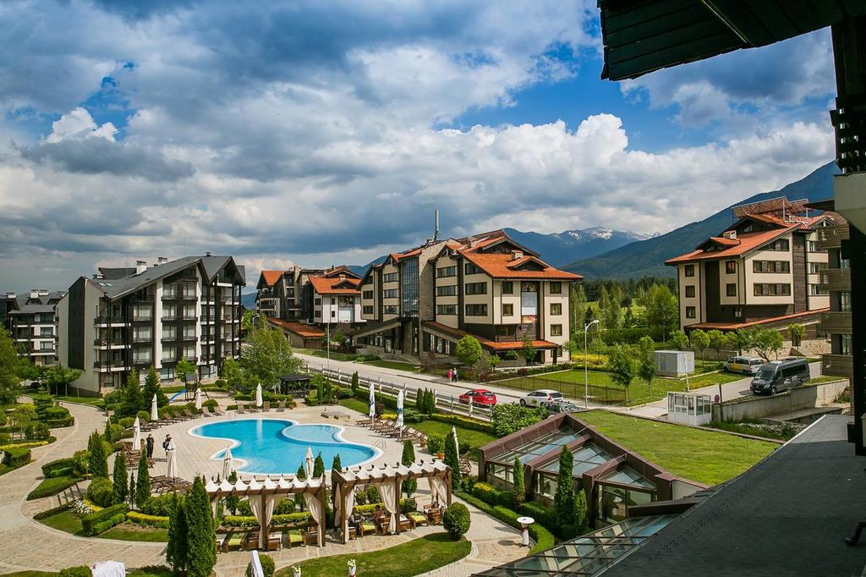
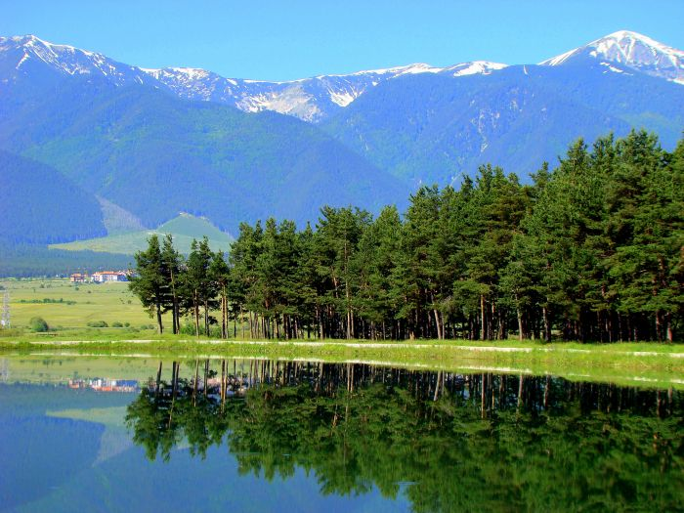

Some Facts about Bulgaria
1.Bulgaria is the only country in Europe that hasn’t changed its name since it was first established. This happened in 681 AD.
2. The oldest gold treasure in the world was found in Bulgaria (in 294 graves were found 3000 gold objects dating back more than 6000 years).
3. Bulgarians shake their heads to mean yes and nod for no.
4. The Bulgarian folk song “Izlel e Delyu Haydutin” by the Bulgarian folk music singer Valya Balkanska was sent in deep space on the board of the US Space Probe – Voyager I, as part of a collection of our civilization’s finest cultural artifacts – a message to an alien intelligence.
5. Lactobacillus Bulgaricus, the bacterium that is responsible for giving Bulgarian yoghurt its unique flavour and consistency, can be found only in Bulgarian air.
6. The Bulgarian army has never lost a single flag in battle.
7. John Vincent Atanasoff was a physicist and inventor of Bulgarian descent, best known for inventing the first electronic digital computer.
8. Nearly one third of Bulgaria is covered in forests.
9. The roses grown in Bulgaria’s “Rose Valley” produce most (70-85%) of the world’s rose oil – a componentin most perfumes.
10. With the accession of Bulgaria to the EU on January 1, 2007, Cyrillic became the third official alphabet of the EU.
11. The first air-dropped bomb in Military History was developed by the Bulgarian Air Force during the first Balkan War and was used on October 16th, 1912 by Lieut. Radul Milkov and Lieut. Prodan Tarakchiev
12. In 1976 UNESCO declared the ancient Bulgarian calendar as the most accurate in the world.
13. Vanga is a famous Bulgarian prophetess. It’s believed that lots of her predictions came true.
14. The Cyrillic script was developed in the First Bulgarian Empire during the 9th century AD at the Preslav Literary School by disciples of the Greek brothers Cyril and Methodius. The Bulgarian Saint Clement of Ohrid is often associated with the creation of the the Cyrillic.
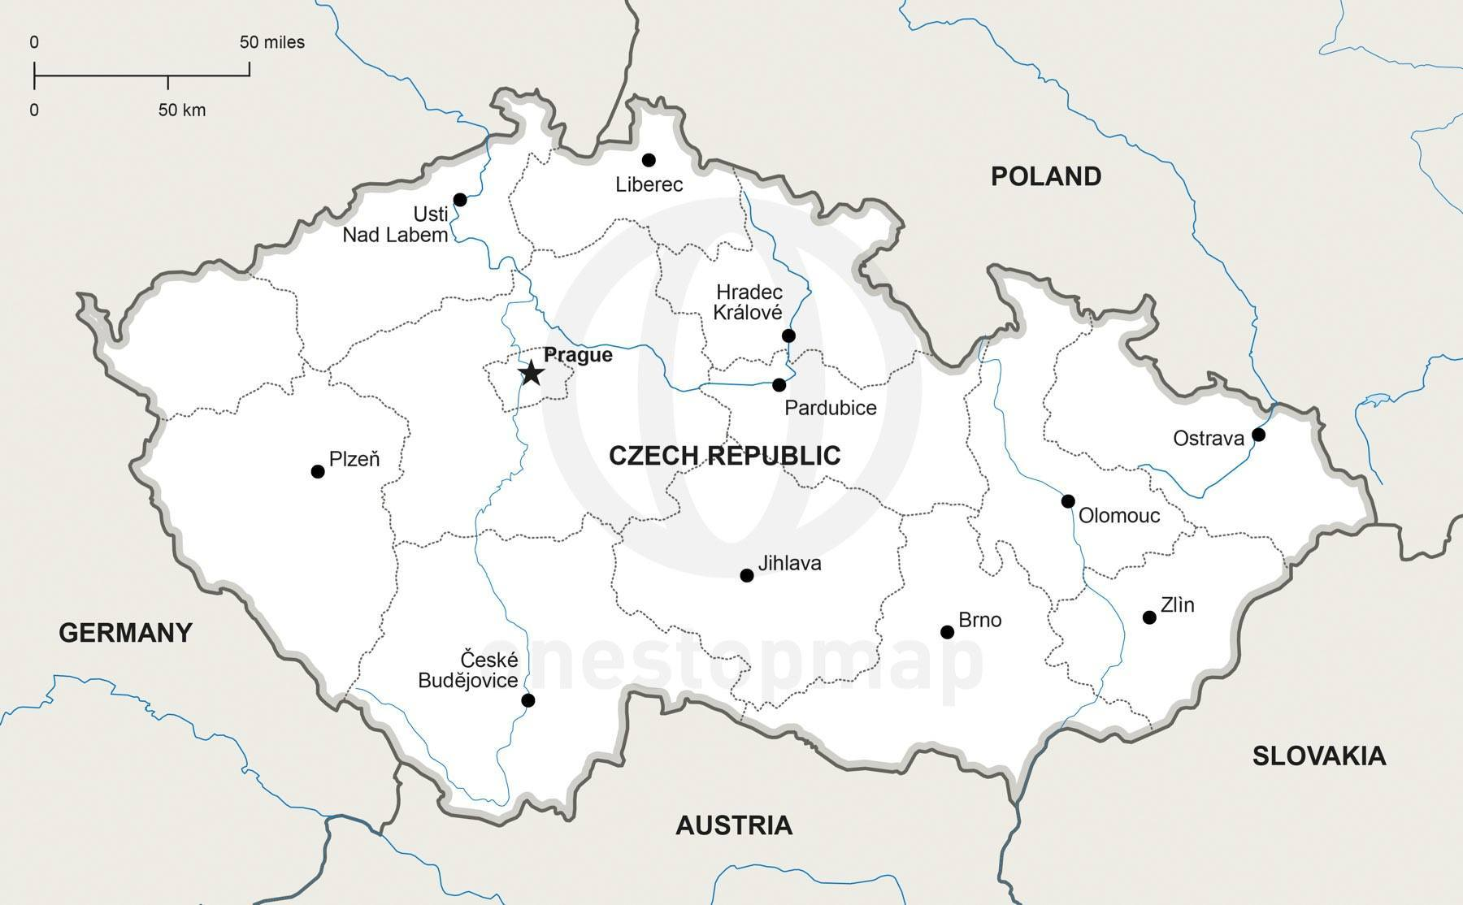
Some Facts about the Czech Republic

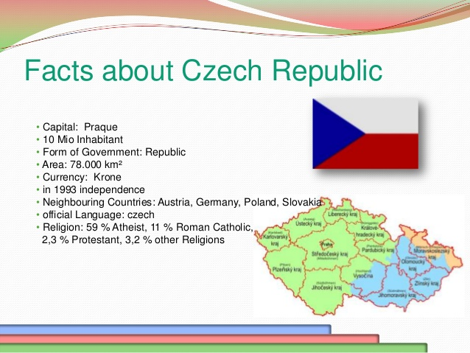

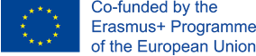
Some Facts about the Czech Republic
Fun fact: The first sugar cubes were made in the Czech town of Dacice in 1841.
Medical fact: Czech doctor Jan Jansky was the first to divide blood into four types in 1907.
Only 16% of Czechs believe in God.The only thing Czechs love more than eating mushrooms, is going mushrooming.
Interesting fact: Czech has the highest castle-density in the world. There are 2,000 in the Czech Republic.
Medical fact: Soft contact lenses were invented by Czech chemist, Otto Wichterle.
Interesting fact: Only 16% of Czechs believe in God.

Interesting fact: Slovakia and Czech Republic were one country in the past. They have been 2 countries since January 1993.

Interesting fact: Czech people drink the most beer in the world. There are a lot of beer festivals in the country, the biggest of which is the Czech Beer Festival held in Prague. It lasts for 17 days and visitors can taste more than 70 brands of Czech beer.

Interesting fact: Skoda Auto brand originates from the Czech Republic. It has a headquartered in Mladá Boleslav and is one of the largest car manufacturers in Central Europe. In 2014, it sold a record number more than a million cars.

Interesting fact: More than 10% of Czech population lives in Prague

Fun Facts about the Czech Republic for Kids
- The capital city is Prague.
- 10,212,000 people live here.
- The official language is Czech.
- 72 percent of people are Christian. Many people are atheist, which means they don’t believe in a God.

More Interesting Facts about the Czech Republic
- The Christmas carol "Good King Wenceslas" was sung about the Czech King who lived here 900 years ago and became patron saint of the country.
- The Czechs are famous for their beer and they drink more per head than any other nation.
- The Sudetan mountains in the west of Bohemia are home to spa towns such as Karlovy Vary, which has 12 natural springs formed by faults in the rock. Famous people, from Beethoven to King Edward VII of England, visited the spa for their health. Locals like to eat sweet wafers called "oplatky" after they have drunk the water.
- Czechs like to eat warming dishes such as pork or duck stew followed by fruit dumplings during the cold winters.
- Czechs are fond of traditional holidays. On January 6th, boys dress up as the Three Kings, Melchior, Balthazar and Kaspar, to get blessed by the local priest.
9 out of 10 Czech people have completed at least secondary education – the highest score in the EU.
The Czech Republic has the most hospital beds per inhabitant in the EU.

